Exercise 2:  
**Part A:**• Create a database called theFizz.

CREATE DATABASE theFizz;

OR

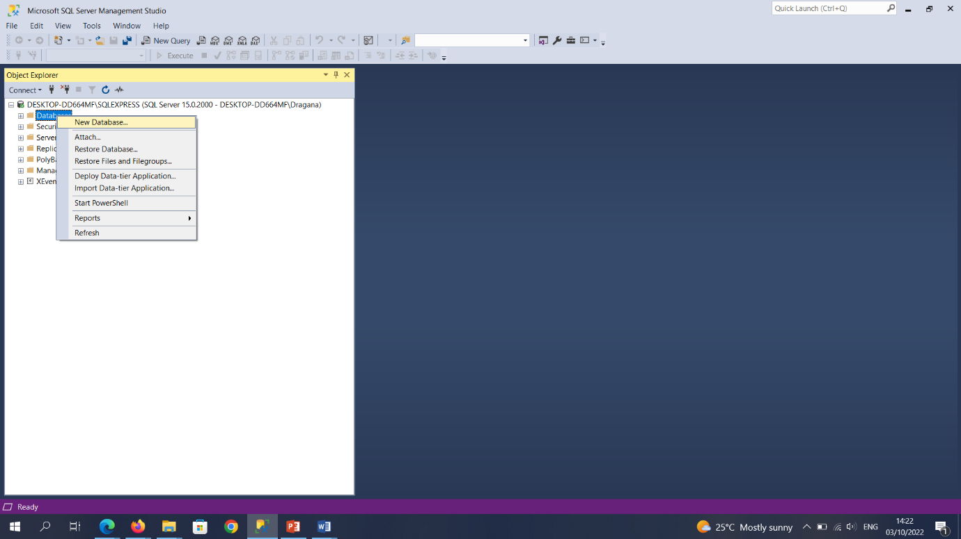

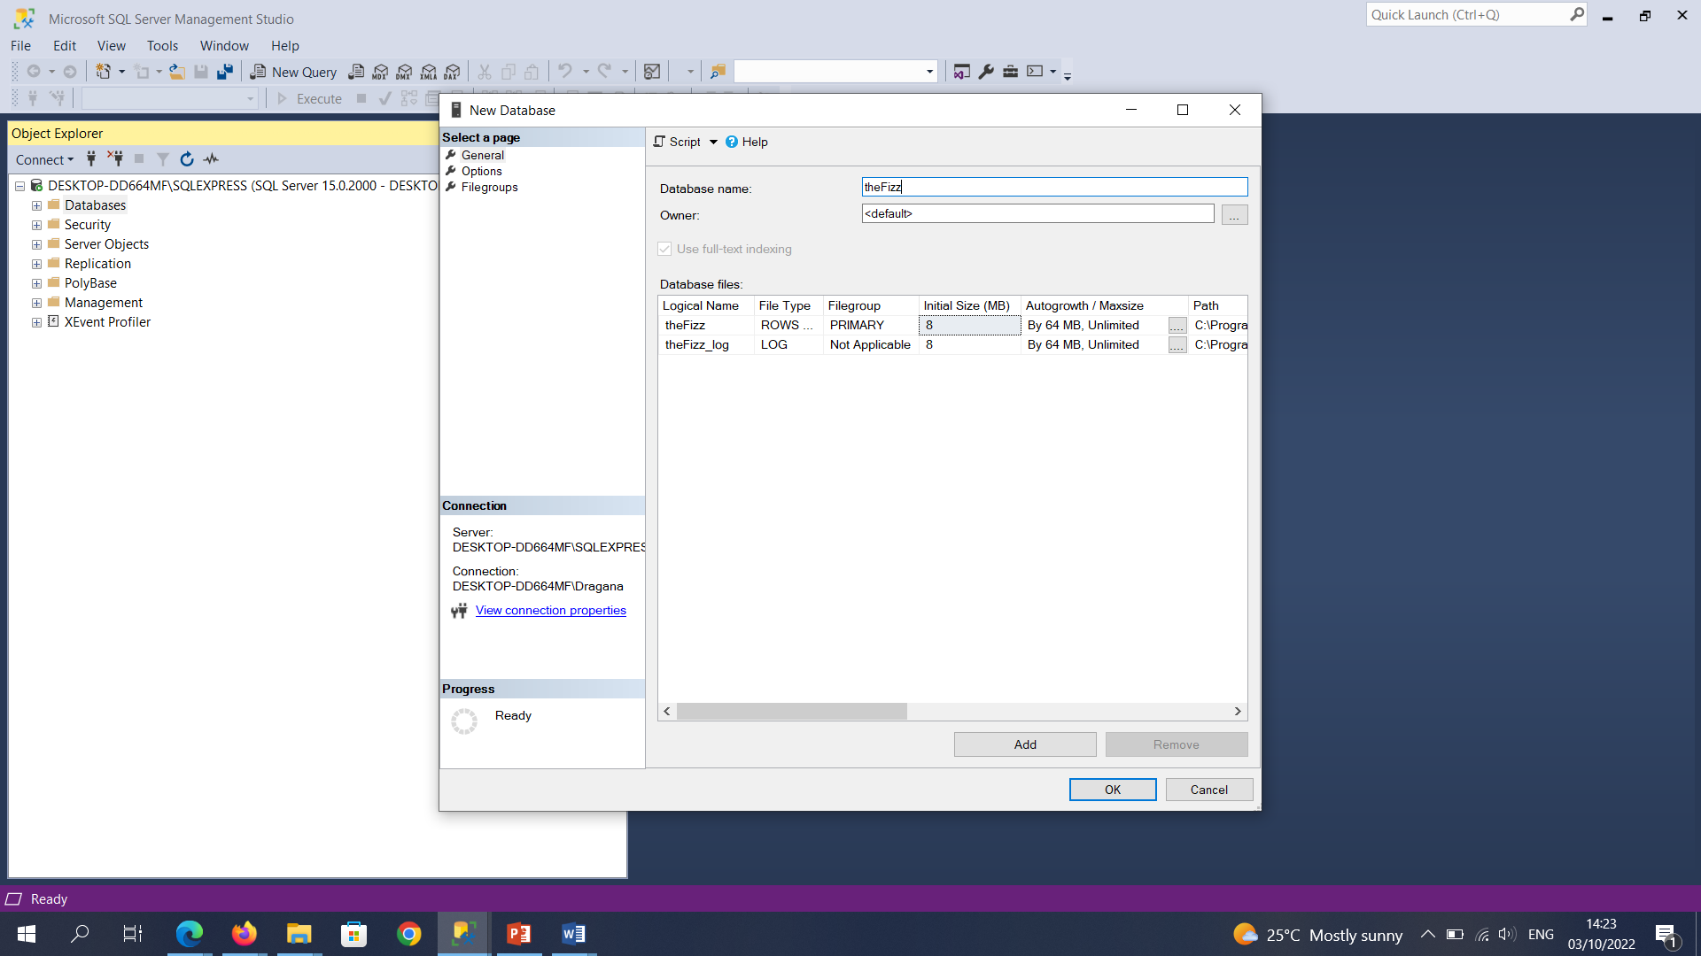

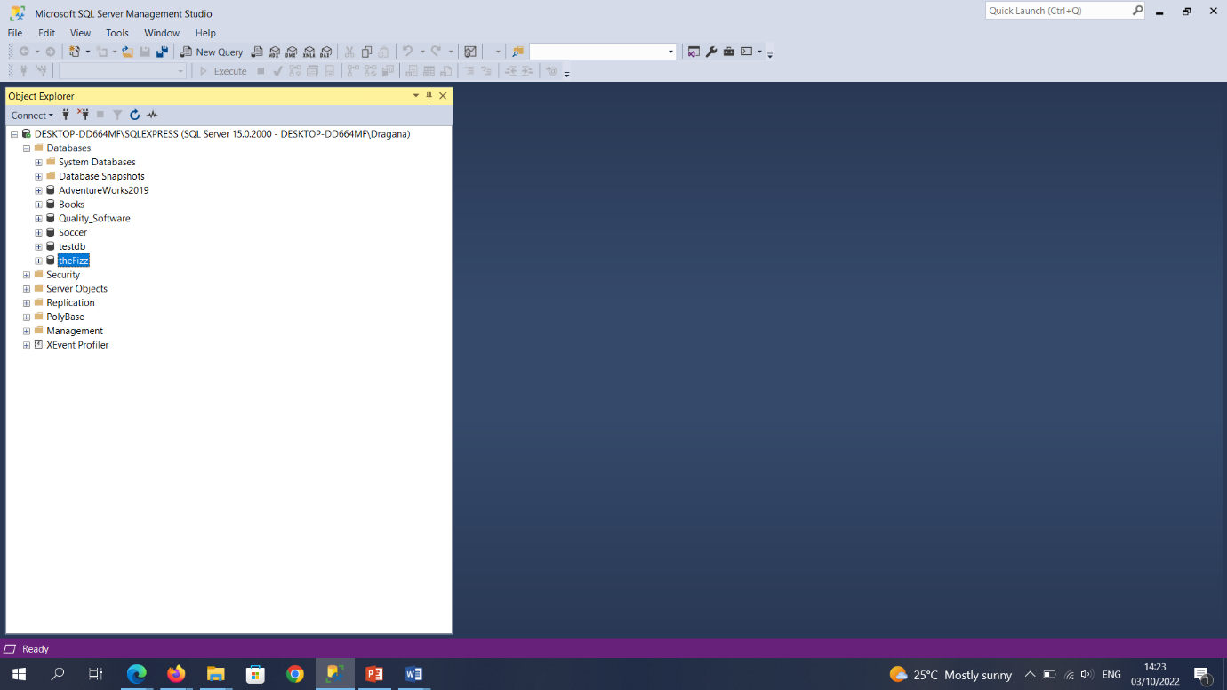

**Part B:**• Create a table called Employees with the following fields…

Field Data Type  
ID (PK) int  
firstName varchar(70)  
lastName varchar(70)  
department varchar(30)  
hireDate date  
telephone varchar(15)  
email varchar(100)

CREATE TABLE Employees (

ID int PRIMARY KEY,

FirstName varchar(70),

LastName varchar(70),

Department varchar(30),

HireDate date,

Telephone varchar(15),

Email varchar(100)

);

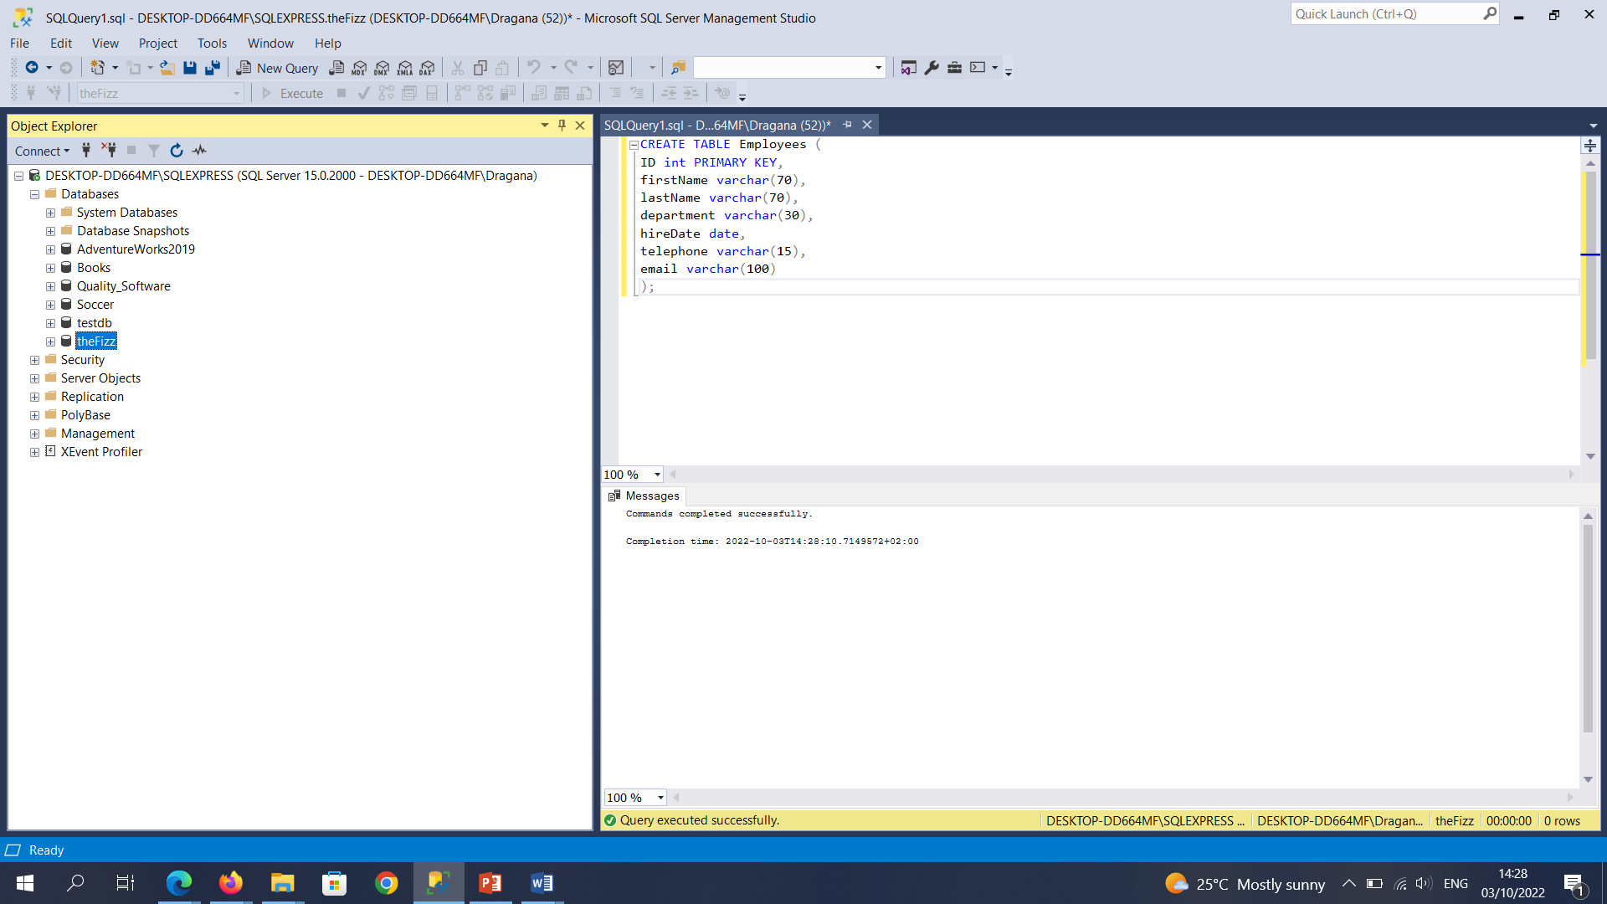

**Part C:**Now make the following changes to the table.

* Include a field to store a PPS No (PPS_No - varchar(10))

ALTER TABLE Employees

ADD PPS_No varchar(10);

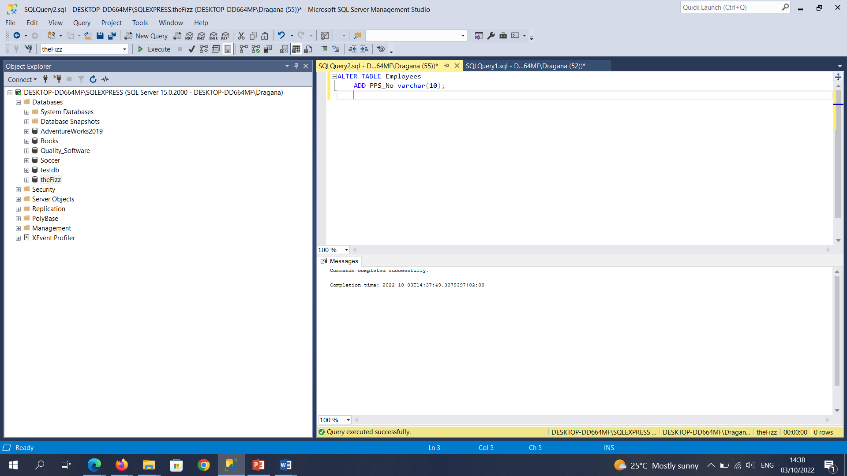

* The PPS_No field should have the not null constraint set.

ALTER TABLE Employees

ALTER COLUMN PPS_No varchar(10) NOT NULL;

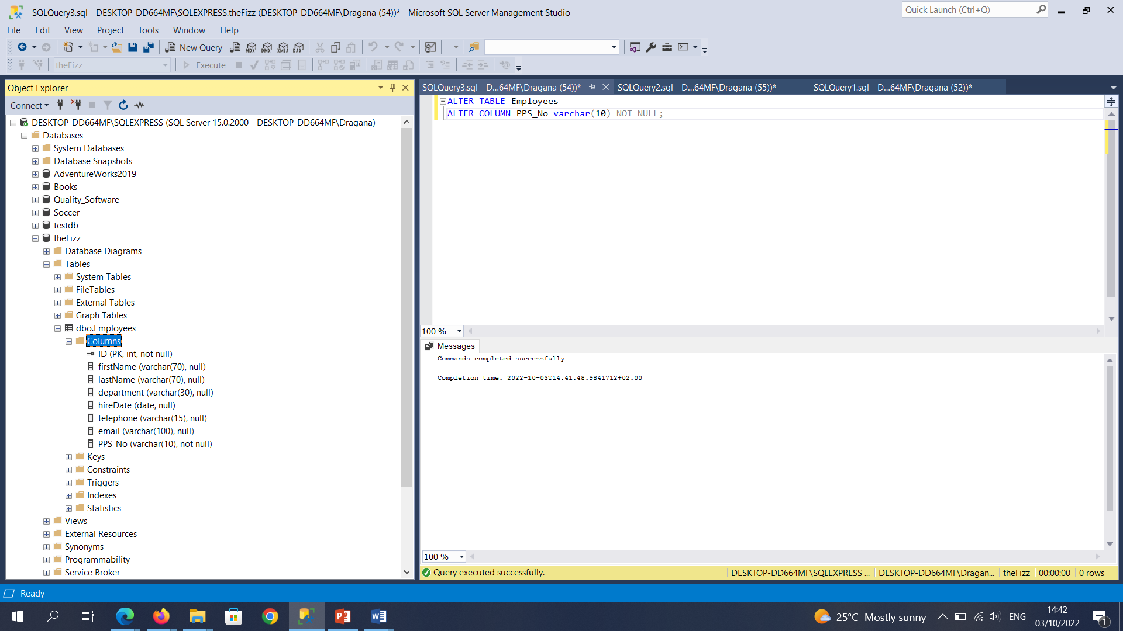

* A nonclustered index should be set on the LastName field to speed up queries made  
  on the table.

CREATE NONCLUSTERED INDEX ndx_LastName

ON Employees (LastName);

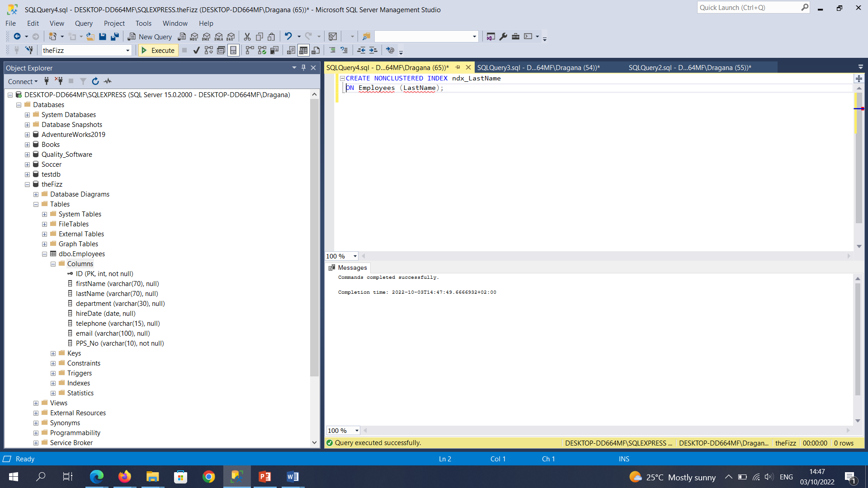

**Part D:**  
• Insert the following records into the table.  
1 Kevin Philips IT ‘2022/01/05’ 013456456 kphillips@thefizz.com 5345615S  
2 Jane Wilson HR ‘2022/01/02’ 013456632 jwilson@thefizz.com 9237119S

INSERT INTO Employees (ID, FirstName, LastName, Department, HireDate, Telephone, Email, PPS_No)

VALUES (1, 'Kevin', 'Philips', 'IT', '2022/01/05', '013456456', 'kphillips@thefizz.com', '5345615S');

INSERT INTO Employees (ID, FirstName, LastName, Department, HireDate, Telephone, Email, PPS_No)

VALUES (2, 'Jane', 'Wilson', 'HR', '2022/01/02', '013456632', 'jwilson@thefizz.com', '9237119S');

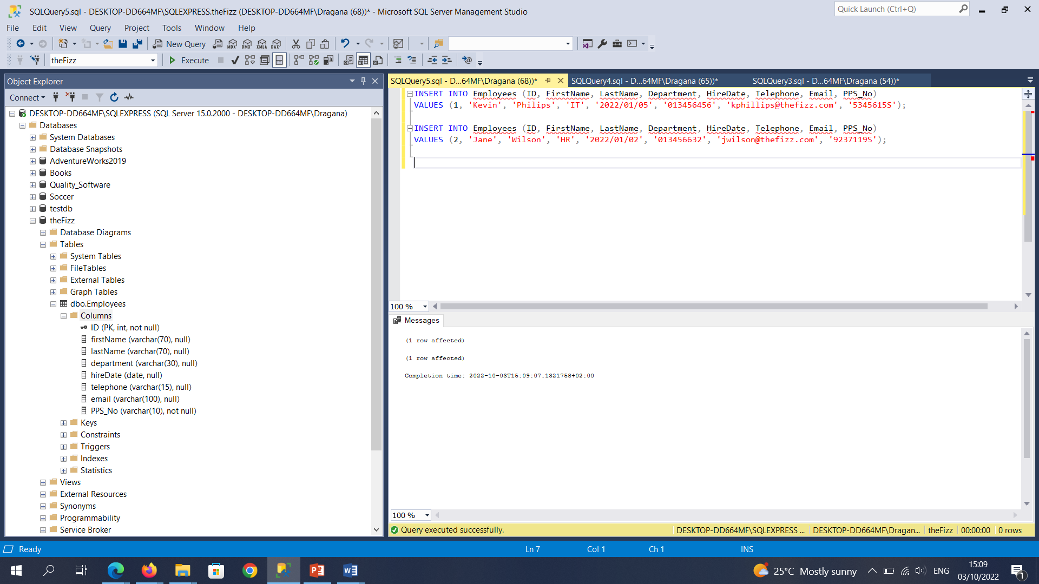

**Part E:**Write a SQL statement that displays all records in the table.

SELECT* FROM Employees;

